Lecture XIV
Narcotic, analgetic drugs
The terms analgesics and analgetic drugs are often used interchangeably to describe a diverse group of pain medications such as opioids, nonsteroidal anti-inflammatory drugs (NSAIDs), and triptans, each with very different mechanisms of action for relieving pains of a wide array of causes. Analgesics can be broadly categorized, according to their therapeutic use, into several drug classes: (a) the opioids (or narcotic analgesics), which play a major role in the relief of acute pain and in the management of moderate to severe chronic pain; (b) the NSAIDs and acetaminophen, which are the most widely used analgesic drugs for relieving mild to moderate pain and reducing fever; (c) the triptans (the antimigraine medications), which are specifically designed and targeted for acute and abortive treatment of migraine and cluster headaches; and (d) a new emerging class of analgesics known as analgesic adjuvants that include tricyclic antidepressants such as amitriptyline, anticonvulsants such as gabapentin and pregabalin, and topical analgesics such as lidocaine patches that can be used to treat neuropathic pains. In this chapter, only the first three classes of pain medications are covered. The main objectives of this chapter will be focusing on their mechanism of action, structure–activity relationships (SARs), pharmacokinetic properties, and their clinical applications for pain management. Readers should consult other chapters under anticonvulsants, antidepressants, and local anesthetics for a detailed discussion of drugs used for treating neuropathic and other incidental pains associated with minor cuts, burns, and insect bites.
Pain, one of the most common complaints for which patients seek medical attention, is also the hardest to manage despite the availability of many analgesic medications as well as other nonpharmacologic treatment options. Pain management, especially the use of opioids in patients with chronic pains, is one of the most troublesome public health issues for patients, doctors, and other healthcare providers.1,2 As early as the 1970s, the National Institutes of Health formed a committee, at the request of the president, to investigate therapies for rare diseases, but the initial focus was on pain management. The committee found that the problem associated with the use of the opioid analgesics was a lack of training of physicians in pain management and misinformation among healthcare providers because of fear of psychological dependence (commonly referred to as addiction), disciplinary action, or adverse effects such as tolerance and physical dependence of the pain medications.2,3 As a result, many patients with moderate to severe pain are often undertreated or untreated.3–5 Another possible reason for treatment failure is the fact that pain perception may also vary among individuals especially across racial and ethnic origins.6 Origin of Pain Pain differs in its underlying causes, symptoms, and neurobiological mechanisms and has been classified into three major types: physiological (nociceptive), inflammatory, and neuropathic.7,8 Physiological pain is the most common and is often caused by an injury to body organs or tissues. It is further categorized, according to the source of the pain, into cutaneous pains (skin and surface tissues), somatic pains (ligaments, tendons, bones, blood vessels), and visceral pains (body organs and internal cavities). Inflammatory pain originates from an infection or inflammation as a result of the initial tissue or organ damage. Neuropathic pain is a very complex, chronic pain, resulting from injury of the nervous systems.9 Neuropathic pain may originate from limb amputation, spinal surgery, viral infections such as shingles, or worsening of disease states associated with diabetes, acquired immunodeficiency syndrome (AIDS), or multiple sclerosis. The pharmacological interventions are very complex and often require the use of other analgesic adjuvants not covered in this chapter. Readers should consult a recent review for a practical guide to the current clinical management of neuropathic pain.10 Acute and Chronic Pain Pain may be acute or chronic.11 Acute pain is often severe but usually lasts only until the removal of the source that triggered the pain. Acute pain includes nociceptive, somatic, or visceral pain, postoperative and posttraumatic pain, burn pain, acute pain during childbirth, acute headache, etc. Acute and postoperative pains are most often treated with the opioid analgesics. Chronic pain, on the other hand, is defined as a pain lasting longer than 6 months that persists even when the initial cause has been resolved through appropriate medical intervention. Chronic pain can be further divided into chronic malignant pain (e.g., cancer, human immunodeficiency virus [HIV]/AIDS, amyotrophic lateral sclerosis, multiple sclerosis, end-stage organ failure) and chronic nonmalignant pain (e.g., lower-back pain, chronic degenerative arthritis, osteoarthritis (OA), rheumatoid arthritis (RA), migraine and chronic headache, and bond pain). Pain therapy in patients with chronic pain only provides transient pain relief but does not resolve the underlying pathological process.7 Chronic pain is also often associated with behavior and psychological components that make effective pain management quite subjective and difficult to resolve.10,12,13 Chronic pain is also the leading cause of disability among the elderly; the prevalence of pain may be as high as 80%.3 Significant advances in understanding the pathophysiology and neurobiology of pain have occurred in the past 10 years.5,13–17 However, a full discussion of complex pain-signaling mechanisms and the etiology of pain is beyond the scope of this chapter. Approaches to Pain Management The World Health Organization (WHO), through its Access to Controlled Medications Programme, has brought together an international, multidisciplinary group of experts to discuss and formulate a series of WHO guidelines, including the “three-step analgesic ladder” on pain management.11,18 The use of the WHO three-step analgesic ladder has allowed physicians to select the most appropriate drug treatment regimen and has resulted in adequate analgesia for their patients, according to a 10-year prospective study published in 1995.18 This guideline has now been adapted for treating other noncancer pains.19 According to this analgesic ladder model (see Fig. 24.1), the choice of analgesic therapy is based on assessment of pain intensity. Thus, nonopioid analgesics such as acetaminophen and NSAIDs are the drugs of choice for mild pain. The patients should continue on this regimen for as long as they are receiving adequate pain control, although an analgesic adjuvant may be added to help relieve the side effects associated with pain medications. For moderate pain, a combination of an NSAID (or acetaminophen) and a weak opioid such as codeine should be used. Morphine, fentanyl, and other potent opioids are reserved only for severe pain, especially in patients who are terminally ill, to control pain and to improve their quality of life.
Opioid Receptor Discovery and Endogenous Ligands There was no direct evidence for the existence of specific opioid receptors until the 1970s when Goldstein et al.20 found that radiolabeled levorphanol bound stereospecifically to certain mouse brain fractions. They hypothesized that this compound bound to an “opiate receptor.” This prediction gained credence in 1973 when additional studies showed that opioid agonists and opioid antagonists compete for the same binding site. Building on these studies, Pert21 was able to show that the pharmacologic potencies of the opioid drugs were proportional to their ability to compete with the antagonist for opioid receptor binding. As it seemed unlikely that these receptors evolved in response to a plant alkaloid, the search for endogenous ligands was intense. The discovery and identification of endogenous substrates for the opioid receptor by Hughes22,23 in 1975 further confirmed the existence of an opioid receptor and intensified the SAR studies of the analgesic opioids. The endogenous peptide ligands for the opioid receptors were originally isolated from pig brains but have been found in every mammal studied. The first
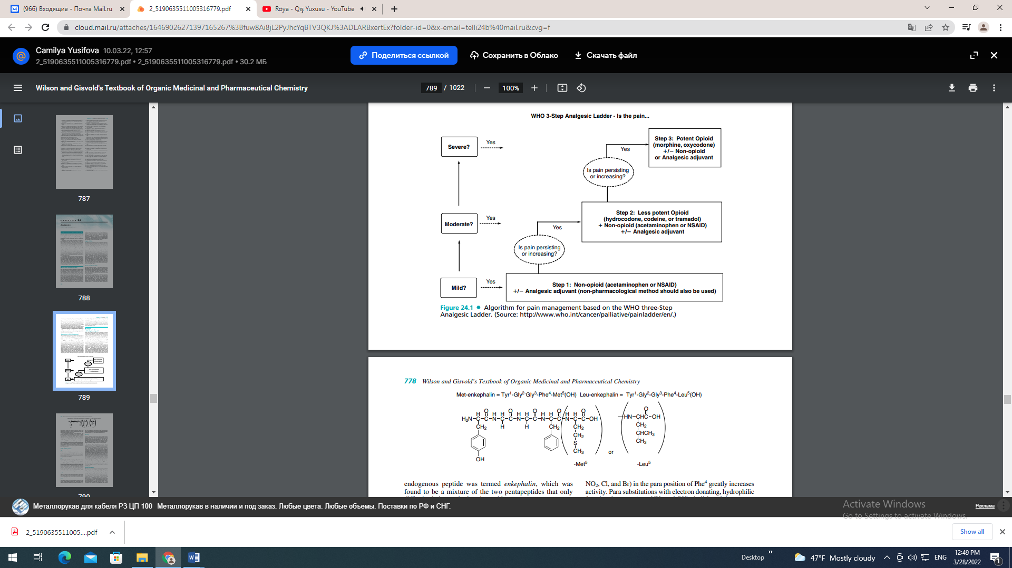
endogenous peptide was termed enkephalin, which was found to be a mixture of the two pentapeptides that only differ in their terminal amino acid. Both methionine-enkephalin (Met-enkephalin) and leucine-enkephalin (Leu-enkephalin) were shown to inhibit the contraction of electrically stimulated guinea pig ileum (GPI) and mouse vas deferens (MVD). These two tests are still used as screening methods for opioid activity. Naloxone completely reversed the inhibitory effects of enkephalin, which led Hughes to infer that the peptides were acting on an opioid receptor.22 The central administration of enkephalins in rats produced short analgesic activity. The transient nature of the enkephalins’ actions correlated with the rapid degradation of the enkephalin Tyr-Gly bond by aminopeptidases. Much synthetic work has been done in an attempt to increase the duration of action of the opioid peptides and maintain their analgesic effect. SARs of Enkephalins TYR1 The first amino acid of the pentapeptide shows a distinct preference for tyrosine. Most changes to this amino acid, either by substituting with other amino acids or masking the phenolic hydroxyl (OH) or amino function, produce an inactive or weakly active peptide. GLY2 Replacing the naturally occurring L-Gly with various D-amino acids produces a peptide that is resistant to peptide cleavage by aminopeptidases. Replacement with D-Ser is the most effective replacement, and all L-amino acid analogs had low activities. Substituting D-amino acids for L-amino acids produces stable peptides, and the stereochemical change may give the peptide access to additional binding sites on the receptors; both of these actions may explain their increased potencies. Replacing the Gly2 with D-Ala2 while simultaneously replacing the L-Leu5 with D-Leu5 produces the peptide known as D-Ala2 , D-Leu5 enkephalin (DADLE), which is commonly used as a selective -agonist. GLY3 Almost all changes to this amino acid result in a drop in potency, unless they are also accompanied by another change such as replacing the Gly2 with D-Ala2 as described above. PHE4 The aromatic nature of the fourth residue is required for high activity. When combined with the D-Ala2 replacement, the addition of an electron withdrawing, lipophilic substituent (e.g., NO2, Cl, and Br) in the para position of Phe4 greatly increases activity. Para substitutions with electron donating, hydrophilic functional groups (e.g., NH2 and OH) abolish activity. MET5 /LEU5 Position 5 appears to tolerate more residue changes than the other positions. Many amino acid substitutions at this position maintain activity (e.g., Ala, Gly, Phe, Pro). Even the loss of the fifth residue to yield the tetrapeptide Tyr1 -Gly2 -Gly3 -Phe4 maintains weak activity in both the GPI and MVD assays. The protected peptide, Tyr1 -D-Ala2 -Gly3 -MePhe4 -Gly-ol5 , known as DAMGO is highly selective for the -receptor. The pituitary gland, hypothalamus, and the adrenal medulla all produce various opioid peptides. Many of these materials were found to be fragments of -lipotropin (- LPT) a 91 amino acid peptide. -LPT has no opioid activity itself. The fraction containing amino acids 61–91 is designated -endorphin (a word derived from combining endogenous and morphine). It is much more potent than the enkephalins in both in vivo and in vitro tests. The search for opioid peptides continued, and additional precursor proteins were discovered. Many additional precursor proteins synthesized in the pituitary, adrenal glands, and brain nerve terminals were found to contain sequences of amino acids that were enkephalins or other active opioid peptides. It appears that naturally occurring peptides may serve roles as both short-acting analgesics and long-term neuronal or endocrine modulators. Acupuncture, running, or other physical activity may induce the release of neuropeptides although studies exist that both confirm and refute these claims.24,25 A complete discussion on the neuropeptides is beyond the scope of this chapter. Some examples of opioid peptides are given in Figure 24.2.26–29 Opioid Receptors The discovery of the endogenous opioid peptides paralleled the development of radiolabeling techniques. During the 1970s, researchers were able to label opioid receptors with reversible radioactive ligands that allowed pharmacological actions of specific receptors and their locations to be identified. These techniques allowed for the identification of opioid receptor locations in the brain. Additional pharmacological advances in gene expression studies led to the identification of peripheral opioid receptor locations.30 Opioid receptors are distributed throughout the brain, spinal cord, and peripheral tissues. The distribution of specific opioid receptor subtypes (, , and ) usually overlaps. In rats, high concentrations of all three genes for the -, -, and -receptors were found in the hypothalamus and cerebral
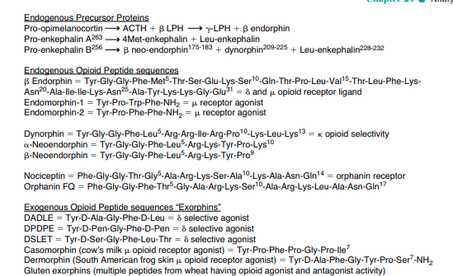
cortex. Intermediate concentrations were found in the small intestine, adrenal gland, testes, ovary, and uterus. Low concentrations of all the three gene transcripts were found in the lung and kidney. The gene for the -opioid receptor was not found in the stomach, heart, endothelium, or synovium of the rat.30 Opioid receptors are also found on the peripheral terminals of sensory neurons in inflamed rat paws.31 Thus, the central and peripheral distribution of opioid receptors is complex. This complicates the interpretation of pharmacological data of individual drugs that may have overlapping binding at multiple opioid receptor subtypes. In addition, opioid receptors form homodimers and heterodimers with opioid receptors and nonopioid receptors such as the 2aadrenergic receptors resulting in different pharmacologic actions and altered coupling to second messengers.32 Genes for the four major opioid receptor subtypes have been cloned; the MOP -receptor (mu for morphine), the KOP -receptor (kappa for ketocyclazocine), the DOP -receptor (delta for deferens because it was originally discovered in the MVD), and the NOP nociception/orphanin FQ receptor (named as an orphan receptor because the endogenous/exogenous ligand was unknown at its time of discovery).33 The opioid receptor subtypes share extensive residue homology in their transmembrane (TM) domains with most of the variation found in the extracellular loops (Fig. 24.3).33 All of the opioid receptors belong to the G-protein–coupled receptor class and as such, they are composed of seven TM domains. When the receptor is activated, a portion of the G protein diffuses within the membrane and causes an inhibition of adenylate cyclase activity. The decreased enzyme activity results in a decrease in cyclic adenosine monophosphate (cAMP) formation, which regulates numerous cellular processes. One process that is inhibited is the opening of voltagegated calcium influx channels on nociceptive C-fibers. This results in the hyperpolarazation of the nerve cell and decreased firing and release of pain neurotransmitters such as glutamate and substance P.34 OPIOID LIGAND BINDING SITE There are no x-ray crystal structures reported for any opioid receptor, and most modeling work has been based on the crystal structure of rhodopsin. Many groups have attempted to find the specific binding site through homology modeling, molecular dynamics, site-directed mutagenesis, chimeric receptors, truncated receptors, and SAR studies. As of yet, no definitive model of the ligand-binding site is available. The opioid-binding site for all four opioid receptors is believed to be an inner cavity formed by conserved residues on TM helices TM3, TM4, TM5, TM6, and TM7.33,35 Not all groups agree that the binding pocket is formed via TM domains; some evidence suggest that the amino terminus is an important determinant of ligand binding affinity as well.36 The ligand specificity that each receptor shows may be a result of differences in the extracellular loops that form lids on the binding cavities or differences in amino acids within the binding cavity. Within the cavity, agonists are thought to bind toward the bottom of the cavity via interactions with a conserved Asp from TM3 and a His from TM6. Molecular modeling calculations show that the phenolic OH of the Tyr1 opioid peptide, or the ring A OH of nonpeptide opioids, forms a hydrogen bond with the conserved His on TM6. The Tyr1 -charged nitrogen, or the N of the nonpeptide agonist, forms an ionic bond with the conserved Asp of TM3. Antagonist ligands are thought to bind deeper in the binding pocket but retain the ionic bond with the Asp of TM3. The bulky substituent on the charged nitrogen of antagonists is believed to insert itself between TM3 and TM6, preventing the shifts required for activation. Thus, antagonists prevent the necessary movement of TM3 and TM6 resulting in functional antagonism.33,35 THE -RECEPTOR Mu receptors are found primarily in the brainstem and medial thalamus.34 Endogenous peptides for the -receptor include endomorphin-1, endomorphin-2, and -endorphin
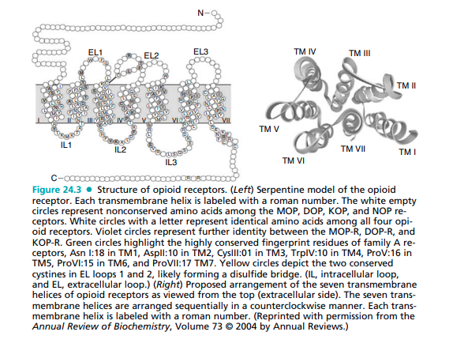
Exogenous agonists for the -receptor include drugs from the five structural classes discussed later in this chapter (4,5-epoxymorphinan, morphinan, benzomorphan, 4-phenyl/4-anilido piperidines, and the diphenylheptanes) and exogenous peptides such as dermorphin isolated from the skin of South American frogs. Recently, human neuroblastoma cells have been shown to be capable of synthesizing morphine via biosynthesis from radiolabeled tyramine. The synthetic route involves at least 19 steps and is similar, but not exact, to the synthetic route used by the poppy plant.37 The exact role of endogenous morphine is unknown at this time. In general, agonists at the -receptor produce analgesia, respiratory depression, decreased gastrointestinal (GI) motility, euphoria, feeding, and the release of hormones. Agonists are also responsible for the addictive effects of the opioid analgesics. Most clinically used opioid drugs bind to the -opioid receptor. THE -RECEPTOR Opioid peptides for the -receptor include the endogenous peptides described previously, Met and Leu enkephalin, as well as some synthetic peptides such as DADLE, DSLET, and DPDPE (see Fig. 24.2 for amino acid sequences). These peptides have high affinity for the receptor but low bioavailability and thus limited clinical usefulness. They are used in animal in vitro studies as probes for -receptor location and function. In an attempt to distinguish the amino acids responsible for -receptor ligand specificity, point mutations of the - receptor, and /-receptor chimeras were constructed.38 The altered receptors had a decreased ability to bind to -receptor selective peptide and nonpeptide ligands, when amino acids in the extracellular top of TM6 and TM7 and the extracellular loop (EC loop 3) that connected them were mutated. Specifically, amino acids Try284, Val296, and Val297 were crucial to selective -ligand binding. These amino acids may provide recognition sites on the receptor that the ligand would have to pass through to reach the putative binding site deeper in the TM cavity. Befort et al.39 also used sitedirected point mutant receptors along with molecular modeling to identify Tyr129 in TM3 as the most crucial amino acid for ligand binding. In addition, they found a role for amino acid Tyr308 (TM7) in ligand binding. Nonpeptide agonists and antagonists have been designed to further study the function of the -receptor. The first nonpeptide lead compound selective for the -receptor came from screening. Modifications to the lead compound led to the identification of SNC-80 as a potent agonist specific for the -receptor (Fig. 24.4). This compound has weak antinociceptive effects in monkeys, an effect that can be reversed with the -antagonist naltrindole (NTI) (Fig. 24.4).40 A series of SNC-80 analog, prepared by multiple groups, found that the amide nitrogen appears to be the most sensitive to modifications and may play an important role in -receptor selectivity.41 Portoghese designed 7-spiroindanyloxymorphone (SIOM) (Fig. 24.4) based on the idea that the indole of NTI is acting as an “address” mimic of the Phe4 phenyl group of enkephalin. The “address–message” concept proposes that one part of the molecule may act as an “address,” essentially directing the chemical to the correct receptor by binding specifically to that receptor, and another part of the molecule acts as the “message,” which gives the compound the biological action. The indole of NTI was replaced with a spiroindane functional group equivalent address in SIOM. The N-methyl group of SIOM confers an agonist message as opposed to the antagonist message of the NTI cyclopropyl methyl.42 Additional agonists for the -receptor have been.
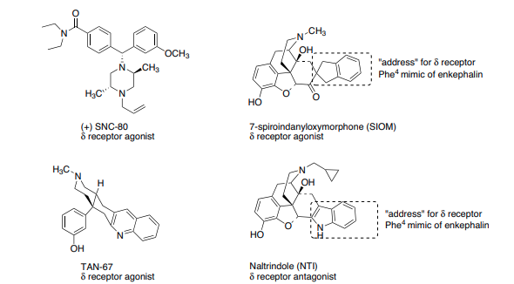
developed based on the octahydroisoquinoline structure with five-membered ring spacers being -receptor antagonists and six-membered ring spacers, agonists. TAN-67 is the most extensively studied in this class (Fig. 24.4).41 The -receptor tolerates multiple chemical structures, and no pharmacophore has been identified that can accommodate all of the diverse structures.38,43 Transgenic mice lacking the -receptor have been generated and found to display increased levels of anxiety. In addition, -receptor agonist show antidepressant activity in rat models.32,44 These results suggest that ligands targeting this receptor may represent new leads for the treatment of schizophrenia, bipolar disorders, and depression. There are few clinical reports of selective -receptor agonist use in humans, although they are reported to have proconvulsive activity that may limit their use.44 THE -RECEPTOR Kappa receptors are primarily found in the limbic, brain stem, and spinal cord.34 The -receptor shows less structural homology to the -receptor than the -receptor does. (Fig. 24.3) Unlike the - and -receptors that bind the (enkephalin) peptide sequence Tyr-Gly-Gly-Phe-(Leu/Met), the -receptor does not. The -receptor shows a clear preference for binding peptides with an arginine in position 6 as seen in the dynorphin peptides (Fig. 24.2).45 The structure of some -agonists and an antagonist can be seen in Figure 24.5.46,47 TRK-820 is a -agonist displaying approximately 15 times selectivity toward -receptors versus -receptors.46 The 4,5-epoxymorphinan structure of TRK-820 is proposed to mimic the tyrosine–glycine moiety of endogenous opioid peptides, in effect the agonist message. The additional 6-substituent constitutes the address directing the compound to the -receptor. Spiradoline was one of the earliest compounds to show improved - receptor selectivity (125 times over -receptors). SARs on this class of compounds revealed that methyl-substituted nitrogen amides, a methylene spacer between the amide and the aromatic ring and the () isomer were all required for - activity. The dichlorophenyl ring could be replaced with a 4- benzothiophene or a 4-benzofuran for increased potency and -receptor selectivity.41 Salvinorin A (Fig. 24.5) a nonnitrogen-containing natural compound found in the herb sage is a potent agonist at the -receptor.48 The hallucinogenic properties of salvia divinorum (sage) have been known for hundreds of years but recently, these properties have been exploited by online groups attempting to sell legal hallucinogenic compounds. The -antagonist nor-binaltorphimine (nor-BNI) was made by incorporating a rigid pyrrole spacer linking two -pharmacophores. Nor-BNI is used in the laboratory to determine if -receptors are involved in an observed activity.41 The second pharmacophore of norBNI is not required for -antagonism, and compounds that are missing the second aromatic ring have been found to be even more selective and potent antagonists at the -receptor. In clinical trials, most -agonists produce dysphoria and thus may be less psychologically addicting but also less acceptable to patients. Some compounds with -agonist activity (e.g., pentazocine, nalbuphine) are available, but the clinical development of pure -agonists has been limited by the centrally mediated side effects. Spiradoline was developed under the premise that a selective -agonist would be an analgesic without the -opioid–mediated problems associated with addiction and respiratory depression. Clinical trials in humans found that spiradoline did not produce analgesic effects within a dose range that did not also cause dysphoria, diuresis, and sedation.47 The selective -agonist TRK-820 shows some promise for the treatment of uremic pruritus, the itch associated with dialysis.49 THE ORPHANIN RECEPTOR/FQ/NOP1 The traditional opioid peptides do not elicit any biological effect at the orphanin receptor. An endogenous peptide for the orphanin receptor has been found and termed orphanin FQ or nociceptin (Fig. 24.2). This 17 amino acid peptide can reverse the analgesic effects of morphine thus is antiopioid
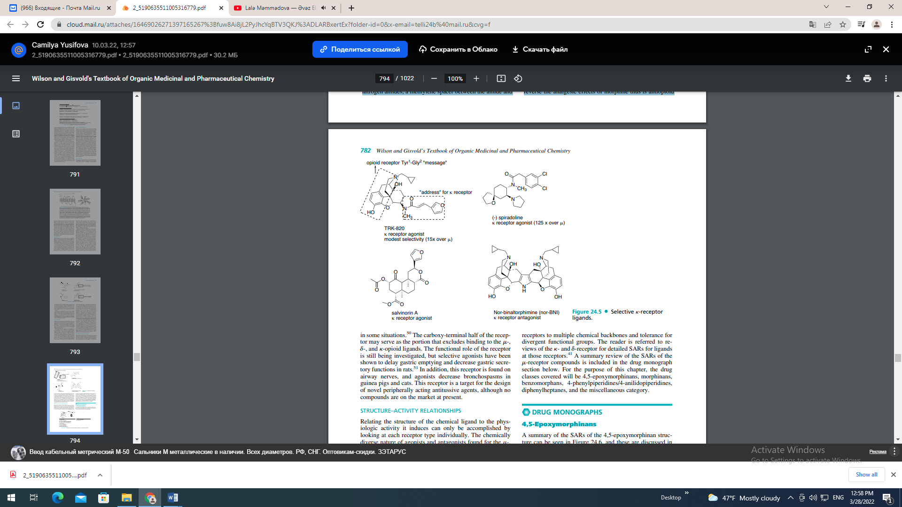
in some situations.50 The carboxy-terminal half of the receptor may serve as the portion that excludes binding to the -, -, and -opioid ligands. The functional role of the receptor is still being investigated, but selective agonists have been shown to delay gastric emptying and decrease gastric secretory functions in rats.51 In addition, this receptor is found on airway nerves, and agonists decrease bronchospasms in guinea pigs and cats. This receptor is a target for the design of novel peripherally acting antitussive agents, although no compounds are on the market at present. STRUCTURE–ACTIVITY RELATIONSHIPS Relating the structure of the chemical ligand to the physiologic activity it induces can only be accomplished by looking at each receptor type individually. The chemically diverse nature of agonists and antagonists found for the -, -, and -receptors is testimony to the adaptability of the receptors to multiple chemical backbones and tolerance for divergent functional groups. The reader is referred to reviews of the - and -receptor for detailed SARs for ligands at those receptors.41 A summary review of the SARs of the -receptor compounds is included in the drug monograph section below. For the purpose of this chapter, the drug classes covered will be 4,5-epoxymorphinans, morphinans, benzomorphans, 4-phenylpiperidines/4-anilidopiperidines, diphenylheptanes, and the miscellaneous category. DRUG MONOGRAPHS 4,5-Epoxymorphinans A summary of the SARs of the 4,5-epoxymorphinan structure can be seen in Figure 24.6, and these are discussed in the succeeding individual drug monographs.
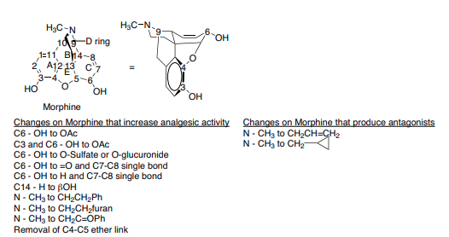

MORPHINE
The prototype ligand for the -receptor is morphine. The numbering and ring lettering (A, B, C. . .) can be seen in Figure 24.6. Morphine contains 5 chiral centers and has 16 optical isomers (not 32 because of the restriction of C-9 to C-13 ethanamino bridge). The naturally occurring, active form of morphine is the levorotatory enantiomorph with the stereochemistry 5(R), 6(S), 9(R), 13(S), and 14 (R). The x-ray determined conformation of morphine is a “T” shape with the A, B, and E rings forming the vertical portion, and the C and D ring forming the top (Fig. 24.6).41 Morphine was isolated from opium in 1806 by a German pharmacist, Seturner. He named the compound “morphine” after the Greek god of dreams “Morpheus.” The first mention of the opium poppy was found in Iraq on clay tablets inscribed in cuneiform script in about 3000 BC. 52 Opium has been used throughout history and is found in ancient Egyptian, Greek, Roman, Arabic, Indian, and Chinese writing. Opium is isolated from the opium poppy, Papaver somniferum, by lancing the unripe pod and collecting and drying the latex that seeps from the incision. Opium contains over 40 different alkaloids with most alkaloids represented in the following five structures: morphine (8%–17%), codeine (0.7%–5%), thebaine (0.1%–2.5%), papaverine (0.5%–1.5%), and noscapine (1%–10%).52 Although the total synthesis of morphine has been accomplished by various chemical processes, it is still produced from the poppy latex.53 Thus far, no synthetic pathway is efficient enough to make it competitive with the preparation of morphine from either isolation or semisynthesis from a precursor compound from the poppy plant. The endogenous synthesis of morphine in human neuroblastoma cells has been elegantly described.37 The function of endogenous morphine is unknown at this time, but the genes and enzymes involved in morphine biosynthesis may become targets for novel drugs used to treat pain. Morphine is the prototype -receptor agonist; it is the drug to which all other -agonists are compared. The pharmacological properties of morphine are well documented and include analgesia, its primary use. For equivalent analgesic effect, the oral dose must be 3 times the intravenous (IV) dose to account for the morphine lost to first-pass hepatic metabolism. The equianalgesic dose of morphine congeners can be seen in Figure 24.7. Morphine is extensively metabolized via phase II conjugation to morphine-3-glucuronide (60%), morphine-6- glucuronide (9%), and, to a lesser extent, the N-demethylated metabolite (3%)54 (Fig. 24.8). Much controversy exists on the contribution of the metabolites of both codeine6-glucuronide and morphine-6-glucuronide to their analgesic effect. In some studies, the 6-glucuronide metabolite of both drugs contributes significantly to their potency.55–57 In other studies, the 6-glucuronide metabolites of morphine and codeine produces very little analgesic effect.58,59 Morphine, or another potent opioid drug, is introduced in the WHO stepladder when pain is severe and no relief is obtained from NSAIDs or a combination of NSAIDs and a less potent opioid. Morphine is a monoacidic base and readily forms water-soluble salts with most acids. Because morphine itself is poorly soluble in water (1 g/5,000 mL at 25°C ), the
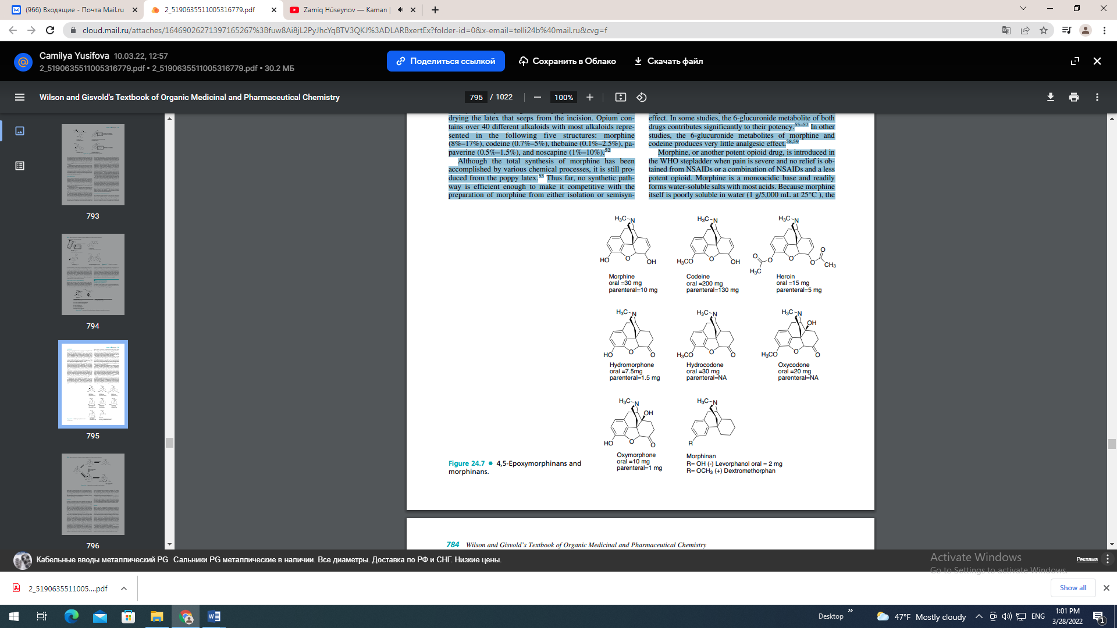
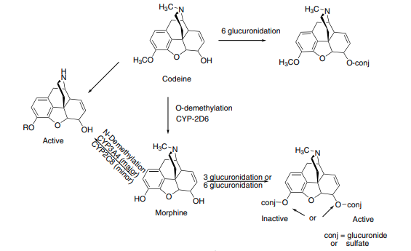
sulfate salt is formed for both oral, IV, and suppository use. The usual starting parenteral dose of morphine in adults is 2.5 to 5 mg q 4 hours. Morphine is available for oral use both as an immediate release and sustained release formulation. The immediate release preparations are dosed q 4 hours, and the sustained release formulations are dosed q 12 to q 24 hours depending on the formulation. CODEINE Codeine is an alkaloid that occurs naturally in opium, but the amount present is usually too small to be of commercial importance. Consequently, most commercial codeine is prepared from morphine by methylating the phenolic OH group. It occurs as levorotatory, colorless, efflorescent crystals, or as a white crystalline powder. It is light sensitive. Codeine is a monoacidic base and readily forms salts with acids, with the most important being the sulfate and the phosphate. The acetate and methylbromide derivatives have been used to a limited extent in cough preparations. The general pharmacological action of codeine is similar to that of morphine, but it does not possess the same analgesic potency. The equianalgesic dose of parenteral morphine 3 to 5 mg q 4 hours is codeine 30 to 65 mg q 4 hours. The equianalgesic dose of oral morphine 10 mg q 4 hours is codeine 60 mg q 4 hours. The decreased potency also leads to a lower addiction potential compared with morphine. Side effects include respiratory depression, mioisis, constipation, nausea, itching, dry mouth, and drowsiness. Approximately 5% of codeine is metabolized to morphine via O-demethylation. (Fig. 24.8) The enzyme responsible for the O-demethylation of codeine is cytochrome P450 (CYP) 2D6. This enzyme exhibits genetic polymorphism with an estimated 7% to 10% of Caucasians designated as poor metabolizers, and thus only able to form traces of morphine after codeine is administered.60 The analgesic component of codeine has long been assumed to be the O-demethylated metabolite, morphine. If codeine has no analgesic potency itself, then patients who lack this enzyme should have no analgesic effect to administered codeine. This has been shown not to be the case, so codeine itself may posses analgesic activity, or codeine-6- glucuronide may be the active analgesic.56,57 Codeine’s role as an effective antitussive agent has been questioned. A Cochrane evidence-based review of the literature shows that codeine is no more effective than placebo for acute cough in children or adults.61 Codeine is available in several combination products with either aspirin, ibuprofen, or acetaminophen for the treatment of moderate pain. HEROIN Heroin, was first commercially synthesized in 1898 by Bayer company in Germany as an alternate analgesic to morphine. Heroin is the 3,6 diacetylated form of morphine (Fig. 24.7). The laboratory researchers, which also used the acetylation process to convert salicylic acid into acetyl salicylic acid (aspirin), believed that heroin would be an effective analgesic with no addictive properties. This was unfortunately not the case. They named the product “heroin” because it made the test subjects, including some of the chemists, feel “heroic.” With both OH groups protected as an ester, heroin can pass through the blood-brain barrier quicker than morphine and lead to the euphoric “rush” that becomes so addictive to addicts, especially after IV injection. Once heroin is in the brain, it is quickly metabolized to 3-acetylmorphine, which has low to zero activity at the -receptor and 6-acetylmorphine, which is 2 to 3 times more potent at the -receptor than morphine.62 Heroin is not available as a prescription product in the United States, although it is available in some countries to treat pain associated with cancer and myocardial infarctions. It remains one of the most widely used narcotics for illicit purposes and places major economic burdens on society HYDROMORPHONE Hydromorphone, (Dilaudid) is a synthetic derivative of morphine prepared by the catalytic hydrogenation and dehydrogenation of morphine under acidic conditions, using a large excess of platinum or palladium.63 Oxidation of the 6- OH of morphine resulted in a compound with decreased potency. Reducing the 7,8 double bond of morphine increased the flexibility of the molecule and resulted in a compound with slightly enhanced binding. Making both of these structural changes to morphine-produced hydromorphone, a compound approximately 5 times as potent as morphine. Hydromorphone was introduced in 1926 and is available as an immediate release tablet, a liquid, and a suppository. A sustained release form is available in some countries but not in the United States. The sustained release form was removed from the U.S. market in 2005 when studies showed that drinking 8 oz of alcohol (40%) could cause the drug to be released from the capsule immediately and lead to concentrations that were 5.5 times higher than in patients that did not drink alcohol. This potentially lethal combination prompted the Food and Drug Administration (FDA) to remove it from the market. HYDROCODONE Hydrocodone is the 3 methoxy version of hydromorphone. The loss of the 3-OH group yields a compound that is approximately 4 to 5 times less potent than hydromorphone, thus about equal to morphine. Unlike codeine, the agonist activity of hydrocodone does not require 3-O-demethylation, although it does occur via CYP2D6 representing 4.6% of total clearance.64 The protected 3-position has better brain penetration, and the 7,8-dihydro-6-keto C ring contributes to the increased binding of the compound to the -receptor. There are no pure hydrocodone products available on the U.S. market. All FDA-approved products containing hydrocodone are combination products. Like codeine, hydrocodone is marketed as an antitussive agent. It is available combined with the anticholinergic agent homatropine as a syrup and a tablet. The addition of the anticholinergic agent is to discourage abuse. It is also available in a delayed release suspension form (Tussionex). This formulation uses a sulfonated styrene divinylbenzene copolymer complexed with hydromorphone and chlorpheniramine that acts as a cation-exchange resin slowly releasing the drugs over a 12- hour period. Hydrocodone is also marketed in combination with acetaminophen (Vicodin, Lortab) or aspirin (Lortab ASA) for the treatment of pain. The dose of acetaminophen consumed by the patient must be closely monitored, and prescriptions that allow for greater than 4 grams of acetaminophen per 24-hour period should not be dispensed. OXYCODONE Oxycodone is synthesized from the natural opium alkaloid thebaine. Oxycodone is the 14 beta-hydroxyl version of hydrocodone. This additional functional group gives oxycodone greater potency (1.5 times orally) than hydrocodone presumably by increasing receptor affinity. The oral bioavailability of oxycodone is 65% to 87%.65 The metabolism of oxycodone follows the similar pattern of opioid metabolism with N-demethylation, O-demethylation, and their glucuronides all identified. Per the manufacturer, the analgesic effect of oxycodone correlates well with oxycodone plasma concentrations, not the minimal amount of oxymorphone formed, thus oxycodone is not assumed to be a prodrug. There are no largescale studies of oxycodone used for analgesia in CYP2D6 poor metabolizers that can confirm this. Oxycodone is marketed in combination with acetaminophen (Percocet), aspirin (Percodan), and ibuprofen (Combunox). It has been available for over 50 years as an immediate-release tablet, and in 1995 an extended-release tablet was approved by the FDA (OxyContin). OxyContin is manufactured in eight strengths from 10 to 160 mg, and the high-dose preparations quickly became attractive to drug abusers. The extended-release tablets are crushed and then injected or snorted to give an immediate high. The Drug Abuse Warning Network (DAWN) is a public health surveillance system that monitors drug-related emergency room visits and drug-related deaths. In 1995, they estimated that 598,542 emergency room visits involved the nonmedical use of a pharmaceutical (e.g., antidepressant, anxiolytic, stimulant). Of these ER visits, 160,363 visits were attributed to opiates with an estimated 42,810 involving oxycodone or an oxycodone combination. Methadone and hydrocodone/combinations were estimated to be similar to oxycodone.66 OXYMORPHONE Oxymorphone is the 14 beta-hydroxyl version of hydromorphone, analogous to the hydrocodone, oxycodone pair discussed above. Although the addition of the 14 beta-hydroxyl group to hydrocodone (30 mg) yielded oxycodone (20 mg), a more potent drug, the opposite is true for the conversion of hydromorphone (7.5 mg) to oxymorphone (10 mg). The reason for this is that the oral bioavailability of oxymorphone (10%) is lower than that of hydromorphone (35%) because of decreased absorption and increased first-pass metabolism. Presumably, the addition of the OH group does increase its binding affinity at the receptor as the injectable form of oxymorphone (1 mg) is more potent than injectable hydromorphone (1.5 mg). Oxymorphone is available as a suppository (5 mg), an injection (1 mg/mL), an immediate-release tablet (5 mg, 10 mg), and in 2003 the FDA approved a sustained release formulation (Opana ER 5 mg, 10 mg, 20 mg, and 40 mg). The 12-hour coverage of the extended release tablet provides another option for those patients suffering from chronic pain. The side effect profile of the extended release formulations of morphine, oxycodone, and oxymorphone are similar, and there appears to be no clear advantage of one over the other. Morphinans The morphinans were made by removing the E ring of morphine, the 4,5-ether bridge, in an attempt to simplify the structure (Fig. 24.7). LEVORPHANOL Levorphanol tartrate is the levorotatory form of methorphan and is approximately 7.5 times more potent than morphine orally. The loss of the 4,5-epoxide and the 7,8-double bond allows levorphanol greater flexibility and presumable leads to the increased binding affinity at all opioid receptor subtypes compared with morphine. The plasma half-life of levorphanol is about 6 to 8 hours but displays great interperson variability and may increase upon repeated dosing. The excretion of levorphanol is dependent on the kidneys, so caution must be used in renally compromised patients.67 0 The analgesic effect of levorphanol may not match the long plasma half-life, and patients must be closely monitored for drug accumulation and respiratory depression. Levorphanol has strong agonist activity at the -, -, and -opioid receptors and has also been shown to be a noncompetitive Nmethyl-D-aspartate (NMDA)-receptor antagonist.68 The pharmacodynamic properties of levorphanol are sufficiently different to make it an attractive alternate for patients that receive inadequate pain relief from morphine. Levorphanol is available as a 2-mg oral tablet (Levo-Dromoran), and a 2-mg/mL solution for injection. DEXTROMETHORPHAN Dextromethorphan is the dextrorotatory form of levorphanol with a methoxy group on the 3-position (Fig. 24.7). It is available in more than 140 over-the-counter (OTC) cough and cold formulations.69 Evidence-based reviews have been unable to conclude that it is more effective than placebo in reducing cough.61,70 Like () and () levorphanol, () dextromethorphan is a potent NMDA antagonist and, in higher than recommended doses, has the potential for causing dissociative anesthetic effects similar to ketamine or phencyclidine (PCP). The OTC status and availability of pure dextromethorphan powder online has contributed greatly to its abuse in recent years. DAWN reports that in 2004, there were approximately 12,500 emergency room visits involving dextromethorphan with 44% of those involving abuse of the drug.71 The 2006 National Survey on Drug Abuse report shows that nearly 1 million persons aged 12 to 25 years (1.7%) misused OTC cough and cold medications in the past year.69 Dextromethorphan’s ability to antagonize the NMDA receptor has led to its use to treat phantom pain, diabetic neuropathy, and postoperative acute pain.72,73 Benzomorphans Structural simplification of the morphine ring system further, by removing the C ring of the morphinan structure, yields the benzomorphans also referred to as the benzazocines.
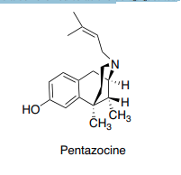
PENTAZOCINE
The benzomorphans are prepared synthetically and thus result in several stereoisomers. The active benzomorphans are those that have the equivalent bridgehead carbons in the same absolute configuration of morphine (carbons 9, 13, and 14 of morphine). The only benzomorphan in clinical use is pentazocine, which is prepared as the 2(R), 6(R), 11(R) enantiomer (Chemical Abstracts numbering).74 Pentazocine is a mixed agonist/antagonist displaying differing intrinsic activity at the opioid receptor subtypes. At the -receptor, pentazocine is a partial agonist and a weak antagonist.
According to the manufacturer, a 50-mg dose of pentazocine has about the same analgesic potency as 60 mg of codeine and about 1/50th the antagonistic activity of nalorphine.74 Pentazocine is also an agonist at the -receptor, and this may be responsible for the higher percentage of patients that experience dysphoria with pentazocine versus morphine.75 Some evidence also exists that women respond better to - agonists than men.76,77 Pentazocine is available in a 50-mg tablet along with a low dose of the antagonist naloxone 0.5 mg (Talwin NX). Naloxone 0.5 mg orally is expected to have no pharmacological effect but is included to dissuade IV drug abusers from dissolving and injecting Talwin NX. 4-Phenylpiperidines and 4-Anilidopiperidines Further structural simplification of the benzomorphan ring system, via removal of the B ring of the benzomorphans yields the 4-substituted piperidines. The resultant structures are flexible and, without the B ring locking the A ring in an axial position relative to the piperidine (D) ring, the A ring can exist in either an axial or an equatorial position. Much SAR work has been conducted on theses compounds, and the reader is referred to Casy’s book for a detailed review.62 MEPERIDINE Meperidine (Demerol) (Fig. 24.9) was discovered in 1939 during a serendipitous screening of compounds being studied for antispasmodic activity. Mice given meperidine were noted to carry their tails in an erect position (the Straub tail reaction), which was indicative of narcotic analgesia. This led to the study of meperidine and derivatives as analgesic agents. Meperidine was found to have low potency at the receptor compared with morphine (0.2%) but much higher penetration into the brain resulting in a compound with about 10% of the potency of morphine.41 Meperidine is an agonist at the -receptor and a 300-mg oral or 75-mg IV dose is reported to be equianalgesic with morphine 30-mg oral or 10-mg IV dose. The 4-ethyl ester was found to be the optimal length for analgesic potency. Increasing or decreasing the chain length decreased activity.41 Structural changes that increase the potency of meperidine include the introduction of an mhydroxyl on the phenyl ring, substituting the methyl on the N for a phenylethyl or a p-aminophenylethyl.41 Replacing the N-methyl with an N-allyl or N-cyclopropylmethyl group does not generate an antagonist, unlike the similar substitution of the morphine congeners. Meperidine quickly penetrates the blood-brain barrier and thus has a quick onset of activity and a high abuse potential. Meperidine is metabolized to normeperidine (Fig. 24.10) by the liver enzymes CYP3A4 and CYP2C18 and in the brain by CYP2B6. Meperidine and normeperidine are also metabolized by liver carboxylesterases.78,79 The metabolism to normeperidine has clinical consequences. The duration of analgesia of meperidine may be shorter than the 3- to 4-hour half-life of the drug. This may necessitate frequent dosing to relieve pain, and thus the excessive formation of normeperidine. Normeperidine has been shown to cause central nervous system (CNS) excitation that presents clinically as tremors, twitches, “shaky feelings,” and multifocal myoclonus potentially followed by grand mal seizures.80 Patients at the greatest risk of developing normeperidine toxicity are those that are on high doses, long durations (greater than 3 days), have renal dysfunction, thus cannot eliminate the normeperidine, and those on CYP inducers.
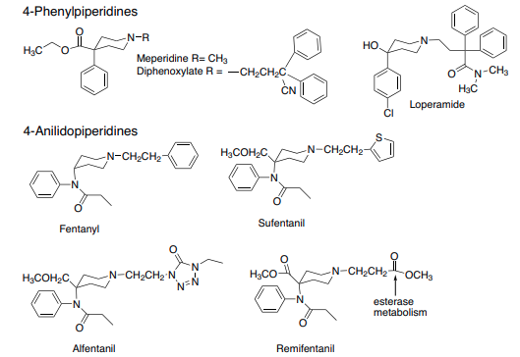
In addition to the CNS toxicity of normeperidine, meperidine has also been found to be a weak serotonin reuptake inhibitor and has been involved in serotonin toxicity reactions when used with monoamine oxidase inhibitors or serotonin reuptake inhibitors.82 Meperidine is available in tablet, liquid, and injectable forms. The use of meperidine should be limited to those patients that have true allergies to the morphine-type opioids, and patients should be monitored for toxicity. DIPHENOXYLATE Diphenoxylate (Fig. 24.9) is a weak opioid agonist and is available combined with atropine (Lomotil) for use as an antidiarrheal agent. At low doses, the opioid effect is minimal, and the atropine is added to dissuade abuse. One study found both codeine and loperamide to be superior to diphenoxylate for treating chronic diarrhea.83 The manufacturer has strict dosing guidelines for pediatric use because opioid intoxication and deaths from diphenoxylate have been reported.84 LOPERAMIDE Loperamide (Imodium) is a 4-phenylypiperidine with a methadone-like structure attached to the piperidine nitrogen (Fig. 24.9). It acts as an antidiarrheal by directly binding to the opiate receptors in the gut wall. Loperamide inhibits acetylcholine and prostaglandin release, decreasing peristalsis and fluid secretion thus increasing the GI transit time and reducing the volume of fecal matter. Loperamide is
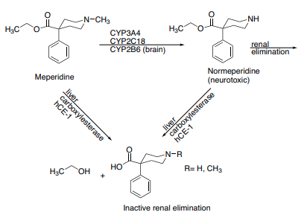
sufficiently lipophilic to cross the blood-brain barrier, yet it displays no CNS-opioid effects. The reason for this is that it is actively pumped out of the brain via the P-glycoprotein pump (MDR1).87 Knockout mice with the P-glycoprotein pump genetically removed were given radiolabeled loperamide and sacrificed 4 hours later. The [3 H]loperamide concentrations were measured and compared with wild-type mice. A 13.5-fold increase in loperamide concentration was found in the brain of the knockouts. In addition, the mice lacking the P-glycoprotein pump displayed pronounced signs of central opiate agonism.87 Loperamide is available as 2-mg capsules for treatment of acute and chronic diarrhea. Recommended dosage is 4 mg initially, with 2 mg after each loose stool for a maximum of 16 mg/d. FENTANYL When the 4-phenyl substituent of meperidine was replaced with a 4-aniline with a nitrogen connection, the potency increased. This led to the development of the 4-anilidopiperidine series of compounds seen in Figure 24.9. Fentanyl (Sublimaze) was the first compound marketed and was found to be almost 500 times more potent than meperidine. The high lipophilicity of fentanyl gave it a quick onset, and the quick metabolism led to a short duration of action. The combination of potency, quick onset, and quick recovery led to the use of fentanyl as an adjunct anesthetic. In addition to the injectable formulation, fentanyl is available in a unique transdermal system (Duragesic). This formulation is beneficial to many chronic pain sufferers unable to take oral medication. The transdermal system releases fentanyl from the drug reservoir patch into the skin, forming a depot layer. The fentanyl is then absorbed into the systemic circulation. Patches are replaced every 72 hours, and serum concentrations of fentanyl can be maintained relatively constant. A transmucosal lollipop form (Actiq) for breakthrough pain only in opioid tolerant cancer patients is also available. The SAR studies of the 4-phenylpiperidine analgesics found that the propionamide is the optimal chain length. Adding polar groups to the 4-piperidine carbon (CH2OCH3 in sufentanil and alfentanil, COOCH3 in remifentanil) increases potency. The piperidine nitrogen of fentanyl contains a phenethyl substituent that appears to be the correct chain length for optimal potency. Molecular docking studies speculate that the phenethyl group of fentanyl binds to a crevice between TM2 and TM3 of the -opioid receptor. This model also aligns the cationic nitrogen of fentanyl with the conserved Asp but leaves the aromatic pocket of the ring unoccupied.88 Substituting the N-phenethyl group with bioisosteres led to the development of fentanyl congeners alfentanil, sufentanil, and remifentanil. ALFENTANIL The addition of a methoxy methyl on the 4-piperidine and the substitution of the phenethyl ring for an ethyl-substituted tetrazole-one yielded a compound with about one fourth to one third the potency of fentanyl (Fig. 24.9). Although less potent, it has a quicker onset of action, a shorter duration of action, and thus a better, safety profile for use as an anesthetic adjunct. The piperidine amine has a pKa of 6.5 compared with fentanyl’s pKa of 8.4. This results in a higher proportion of unionized drug for alfentanil leading to quicker penetration through the blood-brain barrier and thus onset of action.41 Alfentanil (Alfenta) is available as an IV injection for use as an analgesic adjunct for induction of general anesthesia and to maintain analgesia during general surgical procedures. SUFENTANIL Sufentanil (Sufenta) contains the same 4 methoxy methyl substituent as alfentanil along with an isosteric replacement of the phenyl of the phenethyl group with a thiophene ring (Fig. 24.9). The resulting compound is about 7 times more potent than fentanyl with an immediate onset of action and a similar recovery time compared with fentanyl. Sufentanil is only available in an injectable formulation and is also used as an anesthetic adjunct. REMIFENTANIL Remifentanil (Ultiva) was designed as a “soft drug.” Soft drugs are designed to undergo metabolism quickly and thus have ultrashort durations of action. In place of the ethyl aromatic ring seen on the other piperidine opioids, remifentanil has an ester group (Fig. 24.9). This ester group is metabolized by esterases in the blood and tissue to a weakly active metabolite (1:300–1:1,000 the potency of remifentanil).89 The n-octanol/water partition coefficient of remifentanil is 17.9. The pKa of remifentanil is 7.07, thus it is predominately unionized at physiological pH. Both of these properties account for its rapid distribution across the blood-brain barrier (1 minute). The ester hydrolysis leads to a quick recovery (5–10 minutes) independent of duration of drug administration, renal, or liver function. The favorable pharmacodynamics of remifentanil have led to its use for induction and maintenance of surgical anesthesia. Diphenylheptanes METHADONE Methadone (Dolophine) (Fig. 24.11) is a synthetic opioid approved for analgesic therapy and for the maintenance and treatment of opioid addiction. Methadone is marketed as the
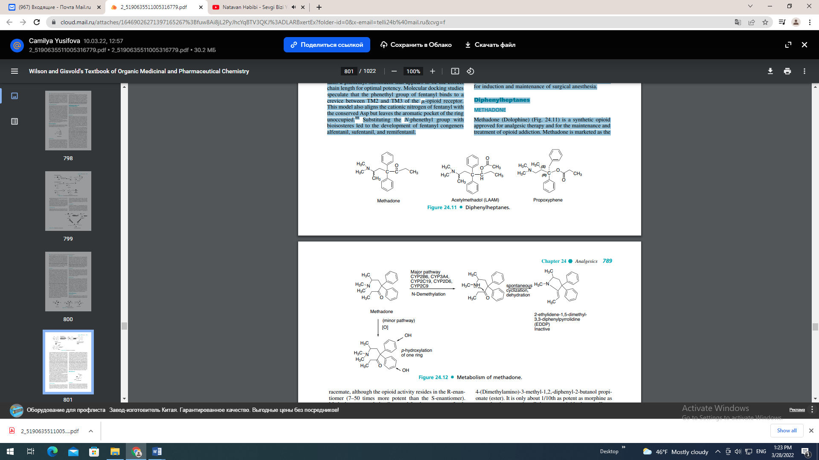
racemate, although the opioid activity resides in the R-enantiomer (7–50 times more potent than the S-enantiomer). Methadone may only be dispensed for the treatment of opioid addiction by a program certified by the Federal Substance Abuse and Mental Health Services Administration. Methadone is a -receptor agonist with complex and highly variable pharmacokinetic parameters. Bioavailability following oral administration ranges from 36% to 100%. Steady-state volume of distribution ranges between 1.0 to 8.0 L/kg. Methadone is highly bound to plasma 1-acid glycoprotein (85%–90%), and t1/2 elimination ranged between 8 and 59 hours. The wide range in parameters leads to difficulty when trying to switch from one opioid to methadone for either treatment of pain or substance abuse. Methadone doses and administration schedules need to be individualized and closely monitored. The metabolism and elimination of methadone also lead to much interpatient variability and can be effected by genetic CYP levels, drug–drug interactions, and the pH of the urine (Fig. 24.12).90 The major metabolic pathway of methadone metabolism is via Ndemethylation to an unstable product that spontaneously cyclizes to form the inactive 2-ethylidene-1,5-dimethyl-3,3- diphenylpyrrolidine (EDDP). Initial reports concluded that CYP3A4 was the major isoform responsible for this pathway, but more recent reports indicate that CYP2B6 is primarily responsible for the N-demethylation.91–95 Adverse effects of methadone include all of the standard opioid effects including constricted pupils, respiratory depression, physical dependence, extreme somnolence, coma, cardiac arrest, and death. In addition, QT interval prolongation and torsades de pointes have been reported. The QT interval prolongation reported for methadone was also observed in another diphenylheptane, levomethadyl, or levo--acetylmethadol (LAAM) (Orlaam) that was also used to treat opioid addiction. The severe cardiac-related adverse events resulted in the removal of LAAM from the U.S. market in 2003. PROPOXYPHENE Most of the structural changes to the methadone skeleton resulted in compounds with decreased opioid potencies, thus most of these compounds, with the exception of LAAM were not developed. Propoxyphene is a derivative of methadone marketed in 1957 as the enantiomerically pure (2S, 3R)- 4-(Dimethylamino)-3-methyl-1,2,-diphenyl-2-butanol propionate (ester). It is only about 1/10th as potent as morphine as an analgesic yet retains all the same opioid adverse effects. One propoxyphene 65-mg capsule has the same analgesic effect of 650 mg of aspirin or 1,000 mg of acetaminophen, thus overdoses of propoxyphene can occur if patients do not follow the prescribed dose. Between 1981 and 1999, 2,110 accidental deaths were reported because of propoxyphene. Propoxyphene and all propoxyphene combination products are listed using the Beers criteria as medications to avoid in patients older than 65 years of age.96 The metabolism of propoxyphene also contributes to the potential dangers of the drug. Propoxyphene is metabolized via N-demethylation to form norpropoxyphene. Norpropoxyphene has been shown to build up in cardiac tissues and result in naloxone-insensitive cardiotoxicity.97 The weak analgesic action and potential risk to the patient have some health practitioners advocating to remove all drugs containing propoxyphene from the market.98 The hydrochloride salt is marketed as Darvon, the napsylate salt as Darvon-N, both salts are also available combined with acetaminophen (Darvocet, Darvocet-N) and a propoxyphene, aspirin, caffeine product is also available.
Miscellaneous
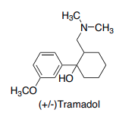
TRAMADOL
Tramadol (Ultram) is an analgesic agent with multiple mechanisms of action. It is a weak -agonist with approximately 30% of the analgesic effect antagonized by the opioid antagonist naloxone. Used at recommended doses, it has minimal effects on respiratory rate, heart rate, blood pressure, or GI transit times. Structurally, tramadol resembles codeine with the B, D, and E ring removed. The manufacturer states that patients allergic to codeine should not receive tramadol, because they may be at increased risk for anaphylactic reactions.99 Tramadol is synthesized and marketed as the racemic mixture of two (the [2S, 3S] [-] and the [2R, 3R] []) of the four possible enantiomers.100 The () enantiomer is about 30 times more potent than the () enantiomer; however, racemic tramadol shows improved tolerability.101,102 Neurotransmitter reuptake inhibition is also responsible for some of the analgesic activity with the () enantiomer primarily responsible for norepinephrine reuptake and the () enantiomer responsible for inhibiting serotonin reuptake.101,103 Like codeine, tramadol is O-demethylated via CYP2D6 to a more potent opioid agonist having 200-fold higher affinity for the opioid receptor than the parent compound. Tramadol was initially marketed as nonaddictive, and a 3-year follow up study showed that the abuse potential is very low, but not zero. Most abusers of tramadol have abused opioid drugs in the past.104 Both enantiomers of tramadol and the major O-demethylated metabolite are proconvulsive, and tramadol should not be used in patients with a lowseizure threshold including patients with epilepsy.
Mixed Agonist/Antagonist
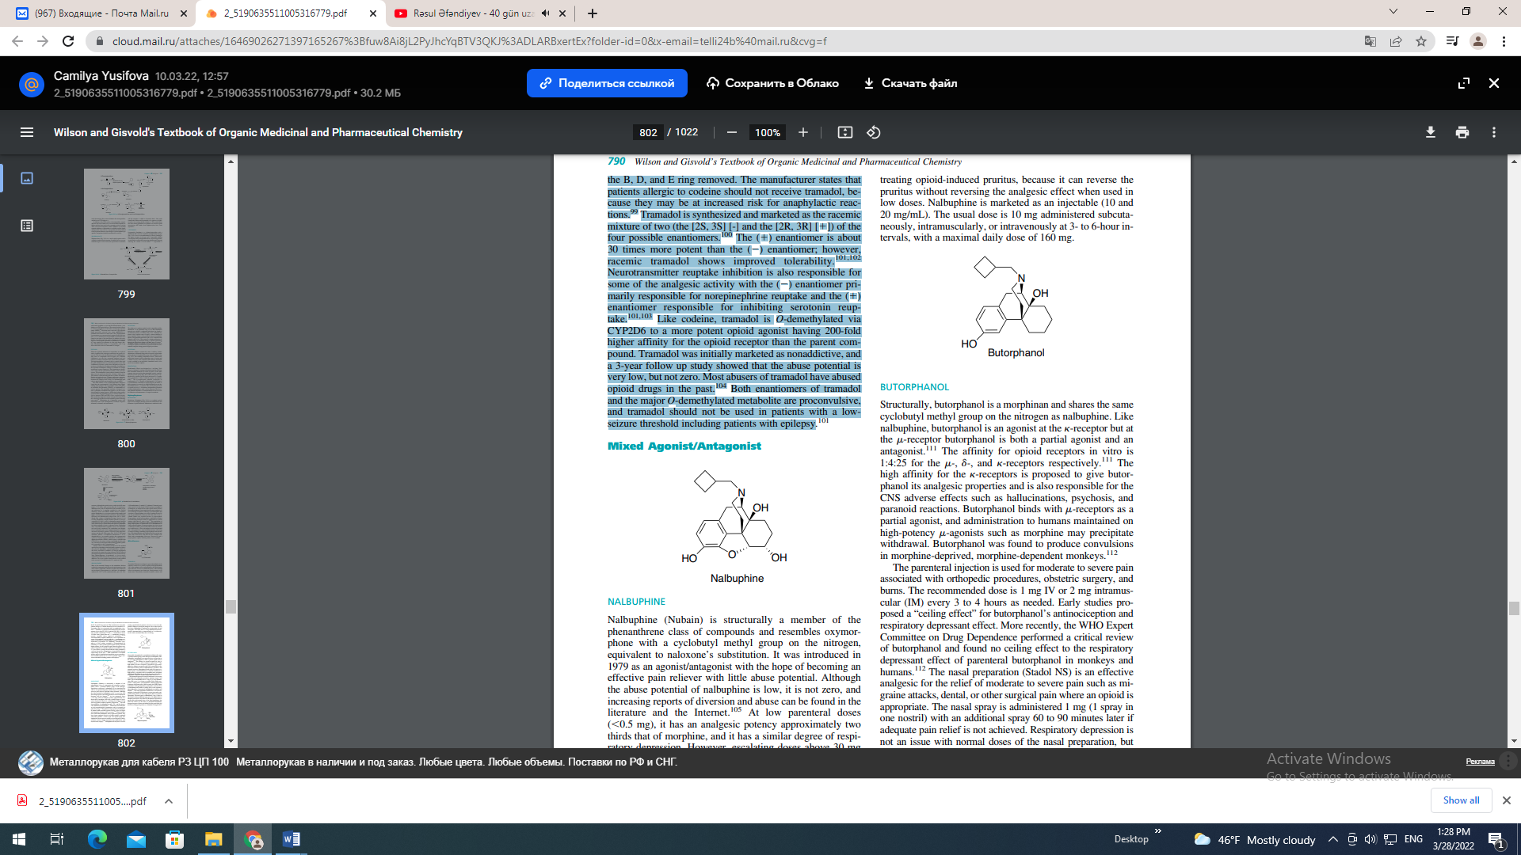
NALBUPHINE
Nalbuphine (Nubain) is structurally a member of the phenanthrene class of compounds and resembles oxymorphone with a cyclobutyl methyl group on the nitrogen, equivalent to naloxone’s substitution. It was introduced in 1979 as an agonist/antagonist with the hope of becoming an effective pain reliever with little abuse potential. Although the abuse potential of nalbuphine is low, it is not zero, and increasing reports of diversion and abuse can be found in the literature and the Internet.105 At low parenteral doses (0.5 mg), it has an analgesic potency approximately two thirds that of morphine, and it has a similar degree of respiratory depression. However, escalating doses above 30 mg does not produce further respiratory depression.106 The oral bioavailability of nalbuphine is only 12%, and the drug is only marketed as an injectable.107 Patents have been filed for an oral extended-release formulation, and it is presently in phase II testing.108 The pharmacologic profile of nalbuphine in animal studies includes agonist activity at the -receptor and antagonist activity at the -receptor.109 Clinical studies have shown that nalbuphine, and -agonists in general, may have better analgesic activity in female patients compared with male patients.77 Used as the sole opioid agent, nalbuphine has been used successfully to treat the pain of labor, cesarean section, dental extraction, hip replacement, and hysterectomy surgery.110 Nalbuphine also may have a role in treating opioid-induced pruritus, because it can reverse the pruritus without reversing the analgesic effect when used in low doses. Nalbuphine is marketed as an injectable (10 and 20 mg/mL). The usual dose is 10 mg administered subcutaneously, intramuscularly, or intravenously at 3- to 6-hour intervals, with a maximal daily dose of 160 mg.
BUTORPHANOL
Structurally, butorphanol is a morphinan and shares the same cyclobutyl methyl group on the nitrogen as nalbuphine. Like nalbuphine, butorphanol is an agonist at the -receptor but at the -receptor butorphanol is both a partial agonist and an antagonist.111 The affinity for opioid receptors in vitro is 1:4:25 for the -, -, and -receptors respectively.111 The high affinity for the -receptors is proposed to give butorphanol its analgesic properties and is also responsible for the CNS adverse effects such as hallucinations, psychosis, and paranoid reactions. Butorphanol binds with -receptors as a partial agonist, and administration to humans maintained on high-potency -agonists such as morphine may precipitate withdrawal. Butorphanol was found to produce convulsions in morphine-deprived, morphine-dependent monkeys.112 The parenteral injection is used for moderate to severe pain associated with orthopedic procedures, obstetric surgery, and burns. The recommended dose is 1 mg IV or 2 mg intramuscular (IM) every 3 to 4 hours as needed. Early studies proposed a “ceiling effect” for butorphanol’s antinociception and respiratory depressant effect. More recently, the WHO Expert Committee on Drug Dependence performed a critical review of butorphanol and found no ceiling effect to the respiratory depressant effect of parenteral butorphanol in monkeys and humans.112 The nasal preparation (Stadol NS) is an effective analgesic for the relief of moderate to severe pain such as migraine attacks, dental, or other surgical pain where an opioid is appropriate. The nasal spray is administered 1 mg (1 spray in one nostril) with an additional spray 60 to 90 minutes later if adequate pain relief is not achieved. Respiratory depression is not an issue with normal doses of the nasal preparation, but CNS side effects are the same as parenteral butorphanol. Increased reports of abuse and addiction of the nasal spray led the FDA to change the product to a Schedule IV drug in 1997.
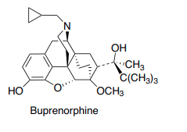
BUPRENORPHINE
Buprenorphine is a semisynthetic, highly lipophilic opiate derived from thebaine. Pharmacologically, it is classified as a mixed -agonist/antagonist (a partial agonist) and a weak - antagonist. It has a high affinity for the -receptors (1,000 times greater than morphine) and a slow dissociation rate leading to its long duration of action (6–8 hours).113 At recommended doses, it acts as an agonist at the -receptor with approximately 0.3 mg IV equianalgesic to 10 mg of IV morphine. One study in humans found that buprenorphine displays a ceiling effect to the respiratory depression, but not the analgesic effect over a dose range of 0.05 to 0.6 mg.114 In practice, this makes buprenorphine a safer opiate (when used alone) than pure -agonists. Relatively few deaths from buprenorphine overdose (when used alone) have been reported.113 The tight binding of the drug to the receptor also has led to mixed reports on the effectiveness of using naloxone to reverse the respiratory depression. In animal studies, normal doses of the pure antagonist naloxone were unable to remove buprenorphine from the receptor site and precipitate withdrawal. In a human study designed to precipitate withdrawal from buprenorphine, a naloxone dose (mean 35 mg) 100 times the dose usually needed to precipitate withdrawal in methadone-dependent subjects was used. For comparison, approximately 0.3 mg, 4 mg, 4 mg, and 10 mg of naloxone would be required to precipitate withdrawal from heroin, butorphanol, nalbuphine, or pentazocine respectively.115 The unique pharmacologic and pharmacokinetic profile of buprenorphine made it a drug of interest for the treatment of opioid dependence. The first study of buprenorphine for this purpose was published in 1978 and confirmed that buprenorphine was an acceptable alternative to methadone for addicts and that it blocked the effects of large single doses of morphine for at least 24 hours.116 Early clinical studies showed that the oral bioavailability of buprenorphine was low because of intestinal and liver metabolism. Therefore, a sublingual (SL) formulation (Subutex) was developed that would bypass this metabolism. The SL tablet has a bioavailability of 55% but varies widely among individuals.116 SL buprenorphine is also available combined with naloxone (Suboxone) in sufficient quantity (25% of the buprenorphine dose) to discourage crushing and injecting the SL tablet. SL naloxone is 0% to 10% bioavailable, and it does not change the absorption or action of the SL buprenorphine. Abrupt withdrawal of chronically administered buprenorphine produces mild to moderate opioid withdrawal symptoms peaking between 3 and 5 days following the last buprenorphine dose. These symptoms require no therapeutic intervention. Suboxone and Subutex are the first medications approved for office-based treatment of opioid dependence under the Drug Addiction Treatment Act of 2000. U.S. pharmacists may only dispense these medications when prescribed by physicians that meet special training criteria and are registered with the Center for Substance Abuse Treatment, a component of the Substance Abuse and Mental Health Services Administration. A transdermal buprenorphine patch is available outside the United States for use in chronic pain.117 This product is currently undergoing phase III clinical trials in the United States. Buprenorphine is oxidatively metabolized by N-dealkylation by hepatic CYP3A4 and to a lesser extent CYP2C8 to the active metabolite norbuprenorphine. Both the parent and major metabolite undergo glucuronidation at the phenolic-3 position. Minor metabolites include hydroxylation of the aromatic ring of buprenorphine and norbuprenorphine at an unspecified site.118 Opioid Antagonists NALTREXONE Naltrexone (Fig. 24.13) is a pure opioid antagonist at all opioid receptor subtypes with the highest affinity for the -receptor. Naltrexone is orally bioavailable and blocks the effects of opiate agonists for approximately 24 hours after a single dose of 50 mg. It produces no opioid agonist effects and is devoid of any intrinsic actions other than opioid receptor blockade. Theoretically, it should work well to treat opioid dependence but in clinical practice, patients have shown poor compliance and high relapse rates. Naltrexone has also been studied to treat alcohol dependence with mixed results. To address the compliance issues and effectively remove the “choice” of taking the antagonist, naltrexone was developed into an extendedrelease injectable microsphere formulation for IM injection once a month (Vivitrol). This formulation provides steady-state plasma concentrations of naltrexone threefold to fourfold higher than the 50-mg oral dose 4 times a day.119 Currently, Vivitrol is only indicated for the treatment of alcohol dependence. A Cochrane review found insufficient evidence from randomized controlled trials to evaluate its effectiveness for treating opioid dependence.120 Currently, phase II and phase III clinical trials of an implantable pellet form of naltrexone are being conducted for treating opioid dependence. The CYP450 system is not involved in naltrexone metabolism. Naltrexone is reduced to the active antagonist 6--naltrexol by dihydrodiol dehydrogenase, a cytosolic enzyme. Naltrexone has a black box warning, because it has the potential to cause hepatocellular injury when given in excessive doses.119 NALOXONE Naloxone (Narcan) (Fig. 24.13) is a pure antagonist at all opioid receptor subtypes. Structurally, it resembles oxymorphone except that the methyl group on the nitrogen is replaced by an allyl group. This minor structural change retains high binding affinity to the receptor, but no intrinsic activity.
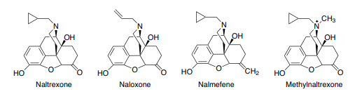
It is used to reverse the respiratory depressant effects of opioid overdoses. Naloxone is administered intravenously with an onset of action within 2 minutes. Because it is competing with the opioid for the receptor sites, the dose and frequency of administration will depend on the amount and type of narcotic being antagonized. Overdoses of long-acting opioids (methadone) may require multiple IV doses of naloxone or continuous infusions. Neonates born to opioid-exposed mothers may be given IV naloxone at birth to reverse the effects of opiates. Very few metabolism studies on naloxone have been conducted, although the major metabolite found in the urine is naloxone-3-glucuronide.121,122 NALMEFENE Nalmefene (Revex) is a pure opioid antagonist that is the 6-methylene analog of naltrexone. It is available as a solution for IV, IM, or subcutaneous (SC) administration to reverse the effects of opioids after general anesthesia and in the treatment of overdose. It is longer acting than naloxone but otherwise has a similar pharmacodynamic and metabolic (3-glucuronidation) profile. Nalmefene has higher oral bioavailability (approximately 40%)123 than naloxone or naltrexone and is currently being investigated as an oral treatment for pathological gambling124 and alcohol abuse.125 METHYLNALTREXONE Methylnaltrexone (Relistor) is the methylated, quaternary form of naltrexone (Fig. 24.13). The permanently charged nitrogen prevents the drug from crossing the blood-brain barrier. Thus, it only acts as an antagonist at peripheral opioid receptors. Relistor was approved in April 2008 to treat opioid-induced constipation in patients receiving palliative care. It is administered as a SC injection once every other day.

PAİN

CHRONİC
AECUTE
NOCİSEPTİV
NEUROPATİC
CENTRAL
PERİFERİC

